Experiment 6
ARP & PPP Configuration

Lab 6 Objectives:
● Observe ARP message exchange and configure PPP with authentication for direct network connections.
Prerequisites: The prerequisites of this lab are-
● Basic networking knowledge (MAC & IP addressing, ARP, PPP).
● Familiarity with command-line tools for network configuration.

Outcomes: By the end of this lab, students will be able to:
● Capture and analyze ARP messages.
● Configure and verify PPP with authentication.
● Troubleshoot ARP and PPP-related issues.

What is ARP (Address Resolution Protocol)?
ARP is used to map IP addresses to MAC (hardware) addresses in a local area network. It is essential for devices to communicate within the same subnet.

How ARP Works:
- If a device wants to send data to another device but only has its IP address, it sends an ARP Request (broadcast).
- The target device replies with an ARP Reply (unicast), providing its MAC address.
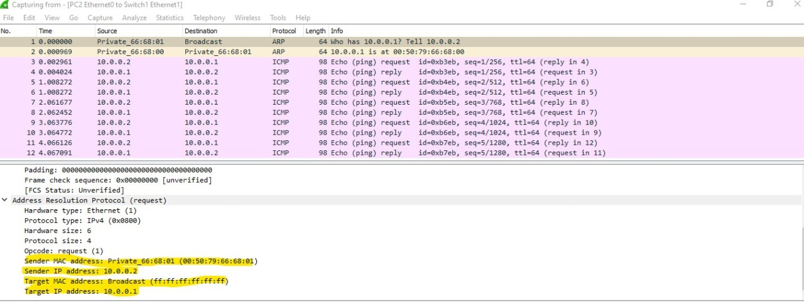
- The sender stores the MAC-IP mapping in its ARP cache.

What is PPP (Point-to-Point Protocol)?
PPP is a data link layer protocol used to establish a direct connection between two networking nodes (usually routers) over serial links.

Features of PPP:
- Supports authentication using PAP or CHAP.
- Encapsulates network layer protocols.
- Error detection and compression.

PPP Authentication Methods:

1. PAP (Password Authentication Protocol):
- Two-way handshake.
- Transmits username and password in plain text.
- Less secure.

2. CHAP (Challenge Handshake Authentication Protocol):
- Three-way handshake.
- Encrypts the password using a hash function.
- More secure.

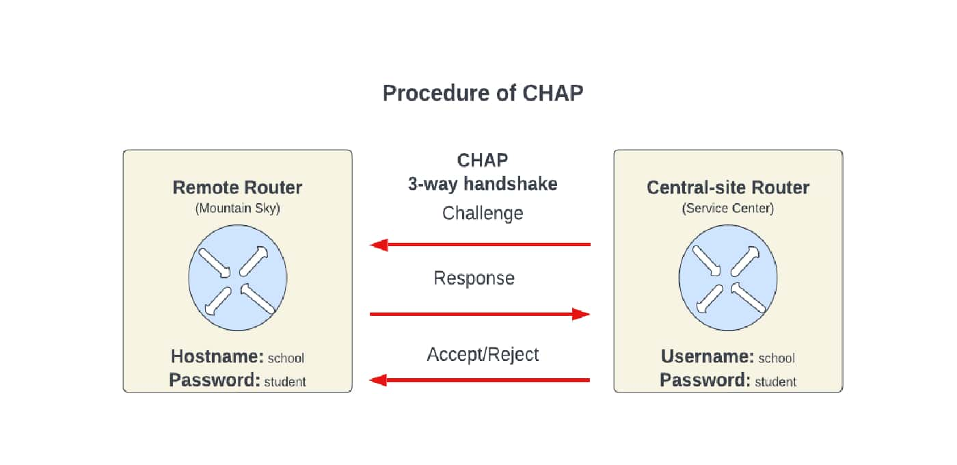

Step 2: Capture ARP Packets (Practical Demonstration)

On PC1 (my laptop), I used the ping command to initiate communication with another device in the same subnet:
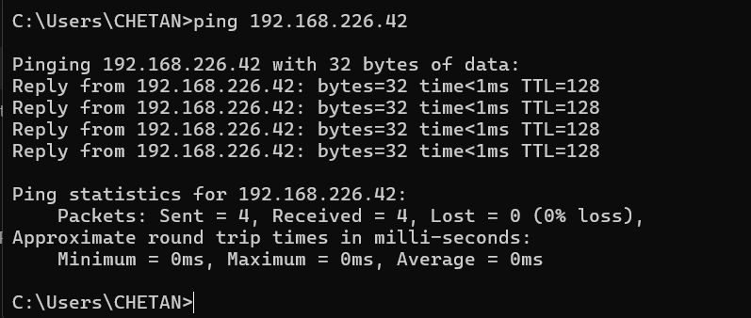

This confirms that the destination device is reachable, and the system successfully resolved the IP address using ARP.
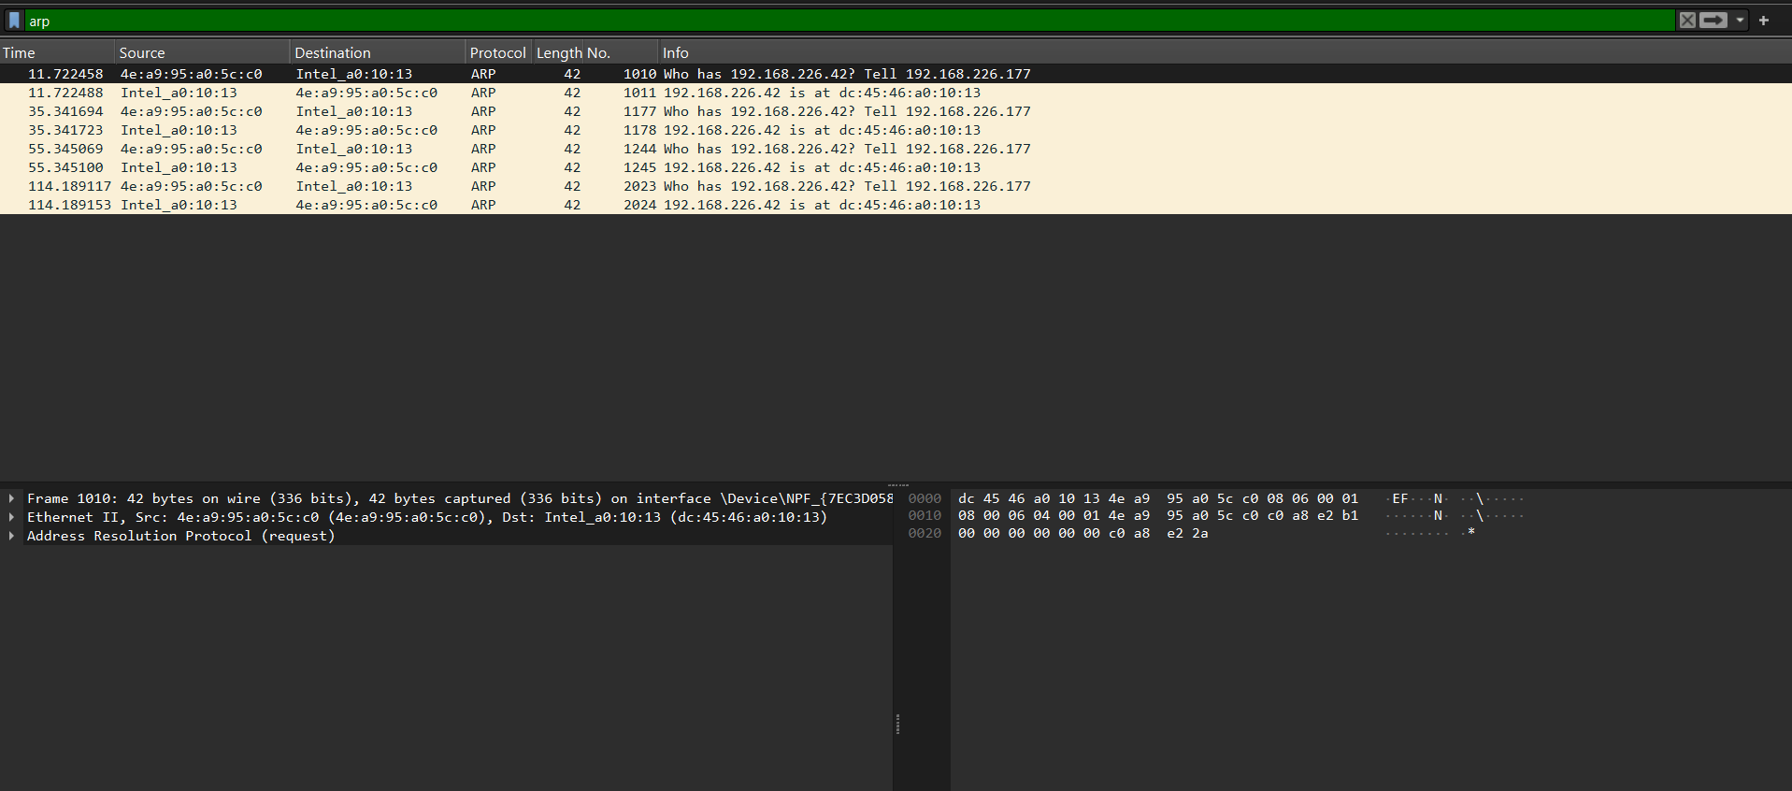
Then, using Wireshark, I captured the ARP message exchange. I applied the filter:
Observation:
ARP Request: Who has 192.168.226.42? Tell 192.168.226.177
ARP Reply: 192.168.226.42 is at dc:65:56:a0:19:93

Configure PPP Between Two Routers – Theory
Objective:
To configure a Point-to-Point Protocol (PPP) connection between two routers using serial interfaces for direct communication.

What is PPP?
Point-to-Point Protocol (PPP) is a Data Link Layer (Layer 2) protocol that is used to establish a direct connection between two networking devices such as routers over serial links. PPP supports:
- Encapsulation of network layer protocols (like IP, IPX)
- Authentication mechanisms (PAP and CHAP)
- Compression and error detection

Why Use PPP?
Although routers by default use HDLC (High-Level Data Link Control) as their encapsulation protocol on serial interfaces, PPP is more versatile and supports
- Multivendor compatibility
- Advanced authentication (PAP/CHAP)
- Link quality monitoring

Therefore, PPP is widely used in WAN (Wide Area Network) links where authentication and reliability are important.

Required Setup:
To configure PPP, we need:
- Two routers with serial interfaces
- A serial (DCE/DTE) cable to connect the routers
- IP addresses on both interfaces that belong to the same subnet

Configuration Commands:
On Router1:
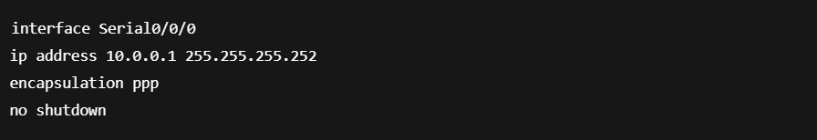
On Router2:
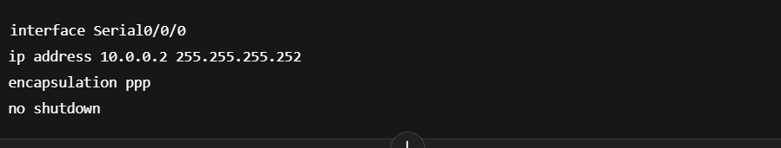
Explanation:
- interface Serial0/0/0: Enters the serial interface configuration mode.
- ip address: Assigns an IP address in the same subnet to the interface.
- encapsulation ppp: Changes the default encapsulation from HDLC to PPP.
- no shutdown: Activates the interface.

Expected Outcome:
After configuring PPP on both routers:
- The serial link becomes active.
- PPP is used for encapsulation.
- The routers can communicate with each other using IP over a PPP link.
- This setup can later be extended to add authentication (CHAP/PAP).

Analysis Report
Experiment Title:
Observing ARP & Configuring PPP Authentication
The primary objective of this experiment was to:
- Understand the working of Address Resolution Protocol (ARP) in mapping IP addresses to MAC addresses within a local network.
- Configure and test Point-to-Point Protocol (PPP) with authentication methods like CHAP to secure communication over serial links.

Findings:
- ARP Functionality:
The experiment demonstrated that ARP plays a vital role in allowing devices to communicate over a LAN by translating IP addresses into MAC addresses. This translation is essential for packet delivery within the same network.
- PPP with CHAP Authentication:
The PPP configuration using CHAP (Challenge Handshake Authentication Protocol) ensured a more secure authentication process between two routers. The CHAP method involves a three-way handshake and periodically verifies the identity of the peer.
Problems Faced:
- Authentication Failure:
Initially, PPP authentication using CHAP failed because the username and password were mismatched between the two routers.
- Missing ARP Packets:
ARP requests and replies were not visible during packet capture when the network cable was disconnected, causing devices to fail in resolving MAC addresses.

Solutions Implemented:
- Correcting Authentication Configuration:
The username and password were rechecked and updated to ensure both routers had matching credentials for CHAP authentication.
- Enabling Interface:
The serial interface was reactivated using the **no shutdown** command, restoring connectivity and allowing ARP packets to be exchanged successfully.

